**Model Documentation: WDE-LSTM Architecture**

This is the documentation for the Word Embedding (WDE) and Long Short-Term Memory (LSTM) model designed for text classification tasks. This model architecture uses word embeddings followed by multiple LSTM layers and dense layers for classification.

**Model Overview:**

The model architecture consists of an embedding layer, multiple LSTM layers, and fully connected dense layers.

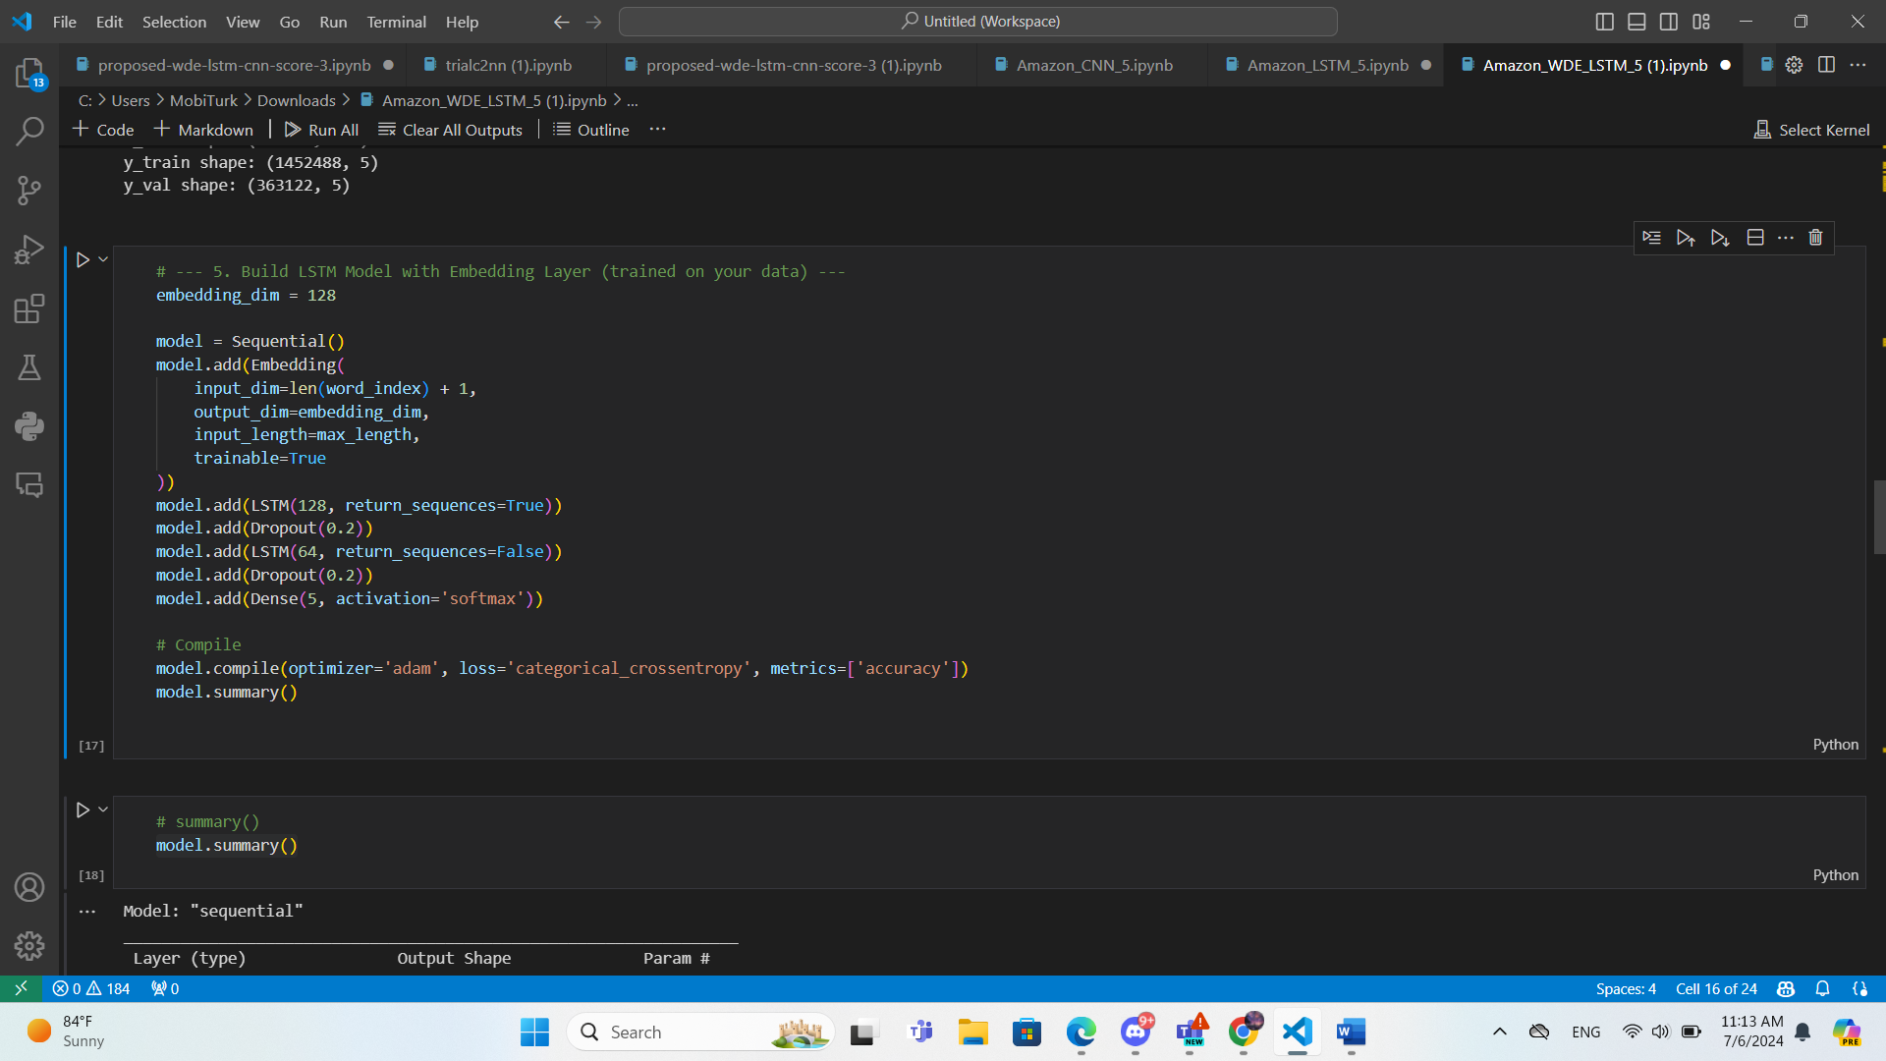**Architecture Diagram:**

**Architecture Description:**

1. **Embedding Layer**:
   * **Input dimension**: vocab_size (size of the vocabulary)
   * **Output dimension**: 128 (embedding vector size)
   * **Input length**: 300 (maximum sequence length)
   * Converts input text sequences into dense vector representations.
   * **Trainable**: True (embeddings will be updated during training)
2. **LSTM Layers**:
   * **LSTM Layer 1**:
     + **Units**: 128
     + **Return sequences**: True (output sequences for the next LSTM layer)
   * **Dropout Layer 1**:
     + **Dropout rate**: 0.2
   * **LSTM Layer 2**:
     + **Units**: 64
     + **Return sequences**: False (output final hidden state only)
   * **Dropout Layer 2**:
     + **Dropout rate**: 0.2
   * Processes the input sequence and captures temporal dependencies.
3. **Output Layer**:
   * **Dense Layer**:
     + **Units**: (5, or 3, or 2)
     + **Activation**: Softmax
   * Performs the final classification.

**Model Compilation:**

* **Loss Function**: Categorical Crossentropy (Binary Crossentropy for score 2)
* **Optimizer**: Adam
* **Metrics**: Accuracy

**Model Summary:**

